ASSIGNMENT-1

SMART HOME APPLIANCE FOR LIGHT

Components:
- Ardiuno Uno R3
- Ultrasonic distance sensor
- LED

Circuit Diagram:

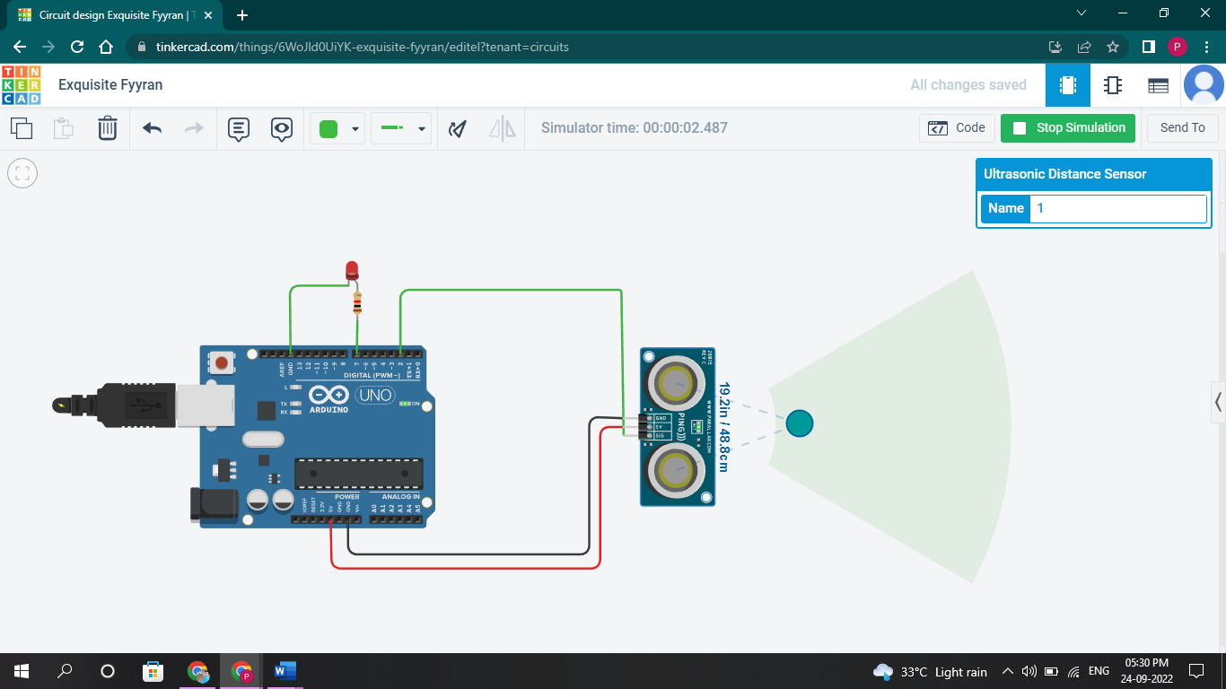

This Circuit will be used for the automatic Light Turn ON/ Turn OFF. In this circuit if the distance of the obstacle(person) is less than 60cm , then the LED will Turn ON and if the distance is Greater than 60cm the LED will Turn OFF.

PROGRAM:
// C++ code
//
long readUltrasonicDistance(int triggerPin, int echoPin)
{
pinMode(triggerPin, OUTPUT); // Clear the trigger
digitalWrite(triggerPin, LOW);
delayMicroseconds(2);
// Sets the trigger pin to HIGH state for 10 microseconds
digitalWrite(triggerPin, HIGH);
delayMicroseconds(10);
digitalWrite(triggerPin, LOW);
pinMode(echoPin, INPUT);
// Reads the echo pin, and returns the sound wave travel time in microseconds
return pulseIn(echoPin, HIGH);
}

void setup()
{
pinMode(7, OUTPUT);
}

void loop()
{
if (0.01723 * readUltrasonicDistance(2, 2) < 60) {
digitalWrite(7, HIGH);
} else {
digitalWrite(7, LOW);
}
delay(10); // Delay a little bit to improve simulation performance
}

